Version Control System Stages

What is Version Control System stages
# Source: AI Source: Provided by: [Data Path: Persons Table -> ID Column: 1, Name_En Column: Motasem Essam] -> From: [ChatGPT] on [2/15/2026]
The stages of a Version Control System (VCS) describe the steps a file goes through from being edited on your computer to being permanently stored and shared in a repository. These stages are especially clear in Git, but the concept applies to most VCS tools.
Here’s a breakdown:

1️⃣ Workspace (Working Directory)
# Source: AI Source: Provided by: [Data Path: Persons Table -> ID Column: 1, Name_En Column: Motasem Essam] -> From: [ChatGPT] on [2/15/2026]
- This is where you edit files on your computer.
- Files here are untracked (new) or modified (existing files changed).
- Nothing is saved in the VCS yet.

2️⃣ Staging Area (Index)
# Source: AI Source: Provided by: [Data Path: Persons Table -> ID Column: 1, Name_En Column: Motasem Essam] -> From: [ChatGPT] on [2/15/2026]
- A temporary area where you prepare files before committing.
- You tell Git which changes you want to include in the next commit.
- Command example:
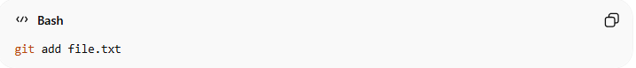
git add file.txt

3️⃣ Local Repository
# Source: AI Source: Provided by: [Data Path: Persons Table -> ID Column: 1, Name_En Column: Motasem Essam] -> From: [ChatGPT] on [2/15/2026]
- The database of committed changes on your local machine.
- When you commit, your staged changes are saved here permanently.
- Command example:
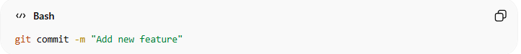
git commit -m "Add new feature"

4️⃣ Remote Repository
# Source: AI Source: Provided by: [Data Path: Persons Table -> ID Column: 1, Name_En Column: Motasem Essam] -> From: [ChatGPT] on [2/15/2026]
- A shared repository on a server (e.g., GitHub, GitLab).
- Others can access your changes once you push them.
- Command example:
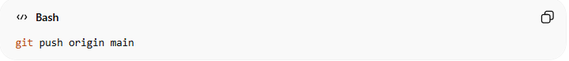
git push origin main

✅ Summary Table:
# Source: AI Source: Provided by: [Data Path: Persons Table -> ID Column: 1, Name_En Column: Motasem Essam] -> From: [ChatGPT] on [2/15/2026]
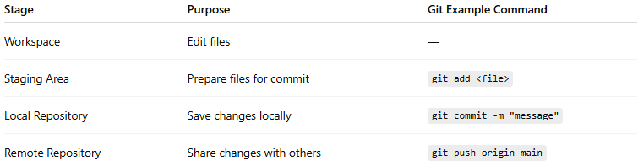
Stage | Purpose | Git Example Command
Workspace | Edit files | —
Staging Area | Prepare files for commit | git add <file>
Local Repository | Save changes locally | git commit -m "message"
Remote Repository | Share changes with others | git push origin main

💡 Think of it as a pipeline for your changes:
Workspace → Staging → Local Repo → Remote Repo
This makes it easier to track, manage, and collaborate on changes.
If you want, I can also make a diagram showing these four VCS stages with arrows, which is super handy for teaching.

